7.1.34 Editors - 3D View - Header - Grease Pencil - Vertex Paint mode - Animation menu
Animation Menu 1
Animation 1
Insert Blank Keyframe ( Active Layer ) 1
Insert Blank Keyframe ( All Layers ) 1
Last Operator Insert Blank Frame 1
All Layers 1
Duplicate Active Keyframe ( Active Layer ) 1
Duplicate Active Keyframe ( All Layers ) 1
Last Operator Insert Blank Frame 1
Mode 2
Delete Active Keyframe ( Active Layer ) 2
Delete Active Keyframe ( All Layers ) 2

Animation Menu
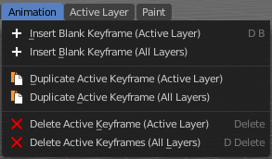

Animation

Insert Blank Keyframe ( Active Layer )
Inserts a keyframe into the active layer.

Insert Blank Keyframe ( All Layers )
Inserts a keyframe into all layers.

Last Operator Insert Blank Frame
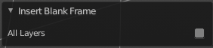
Some snap operations shows a last operation panel, some not.

All Layers
Insert into active layer or into all layers.

Duplicate Active Keyframe ( Active Layer )
Duplicates the active keyframe in the active layer.

Duplicate Active Keyframe ( All Layers )
Duplicates the active keyframe in all layers.

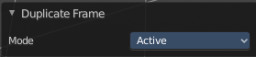
Last Operator Insert Blank Frame
Some snap operations shows a last operation panel, some not.

Mode
Duplicate the active keyframe in the active layer or in all layers.

Delete Active Keyframe ( Active Layer )
Deletes the active keyframe in the active layer.

Delete Active Keyframe ( All Layers )
Deletes the active keyframe in all layers

